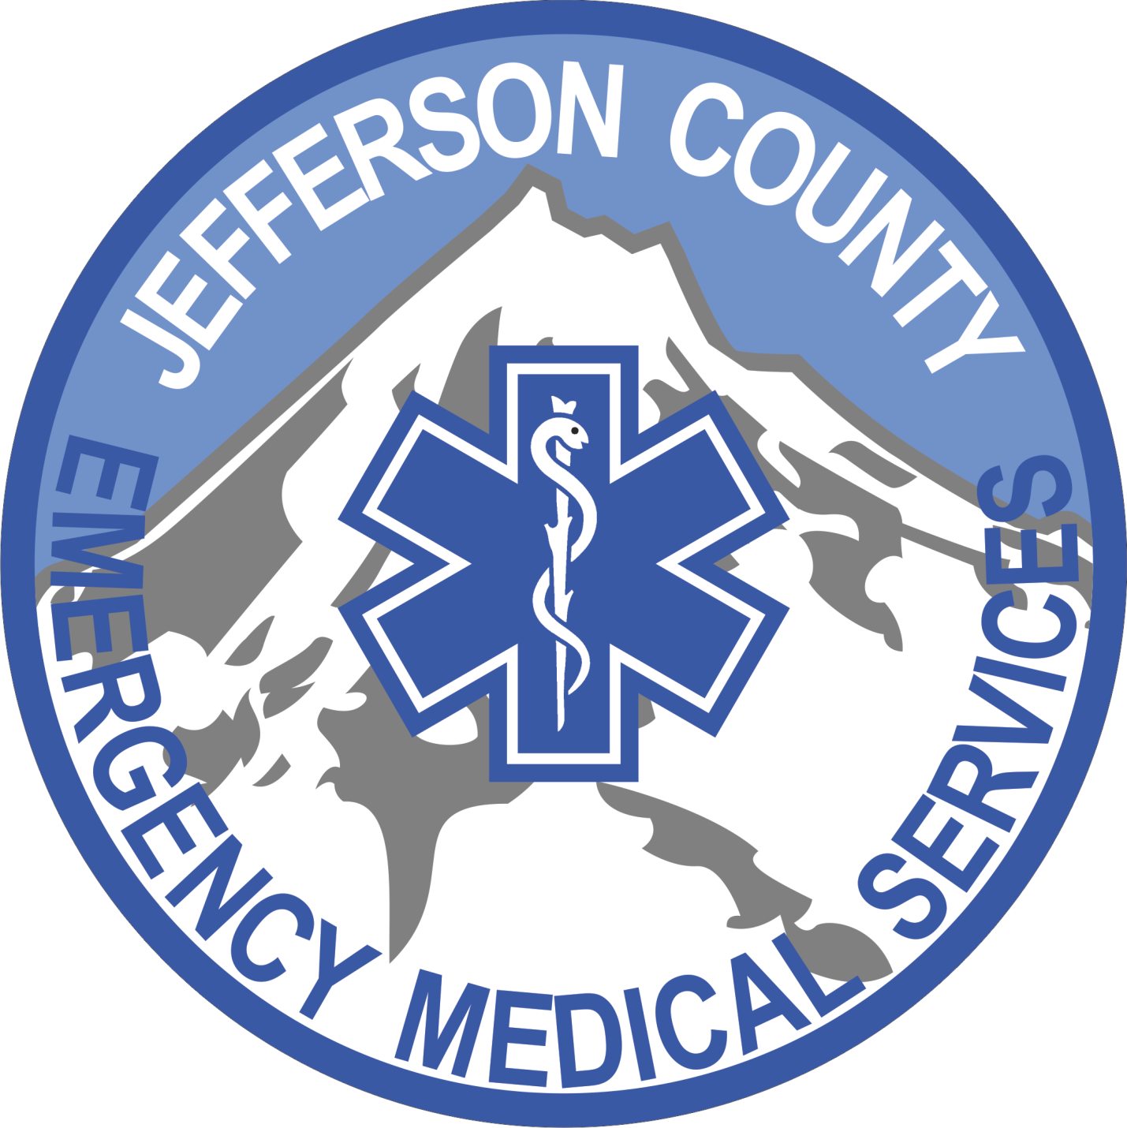
Jefferson County
Emergency Medical Services District
Standard Operating Guidelines
(SOGs)
Updated October 14, 2019
Table of Contents
Section 100 – Management and Administration
100.00 – General Rules & Administration
100.01 – Mission, Vision, Statement of Core Values & Motto
100.02 – Organizational Structure
100.03 – Chain of Command
100.04 – Duties and Responsibilities of EMS Field Personnel
100.05 – Duties and Responsibilities of Duty Officer
100.06 – Uniform Policy
100.07 – Professional Appearance Standard
100.08 – Station Duty Assignments
100.09 – Station Security
100.10 – Code of Conduct
100.11 – Code of Officer Conduct
100.12 – Mobile Device Usage Policy
100.13 – Smoking Policy
100.14 – Substance Abuse
100.15 – Accident/Injury Reporting and Procedures
100.16 – Meetings
100.17 – Turnout and Response Time Standard/Goals
100.18 – Dereliction of Duty
100.19 – Quality Assurance/Performance Improvement Committee and Strategic Plan
100.20 – Credit Card Use
100.21 – Expense Reimbursements
100.22 – Ride-Along Policy
100.23 – Station Living Area
100.24 – HIPAA Compliance – Overview & Manual (In Development)
100.25 – Email & Electronic Equipment
Accident/Injury Reporting and Procedures 100.15
Chain of Command 100.03
Code of Conduct 100.10
Code of Officer Conduct 100.11
Credit Card Use 100.20
Duties and Responsibilities of EMS Field Personnel 100.04
Duties and Responsibilities of Duty Officer 100.05
Dereliction of Duty 100.18
Email & Electronic Equipment 100.25
Expense Reimbursements 100.21
HIPAA Compliance – Overview & Manual (In Development) 100.24
Meetings 100.16
Mission, Vision, Statement of Core Values & Motto 100.01
Mobile Device Usage Policy 100.12
Organizational Structure 100.02
Professional Appearance Standard 100.07
Quality Assurance/Performance Improvement Committee and Strategic Plan 100.19
Ride-Along Policy 100.22
Smoking Policy 100.13
Station Duty Assignments 100.08
Station Security 100.09
Station Living Area 100.23
Substance Abuse 100.14
Turnout and Response Time Standard/Goals 100.17
Uniform Policy 100.06
101.00 – Human Resources
101.01 – Duty Schedule
101.02 – Calling Out Sick and Sick Leave
101.03 – Secondary Employment and Volunteerism
101.04 – Employee Benefits
101.05 – Lay Off
101.06 – Duty Hours and Attendance Policy
101.07 – Time-Off (& Vacation, Bereavement & Maternity Leave) Policy
101.08 – Licensure Requirements
101.09 – Reserved
101.10 – Vacant Shifts – Overtime Policy
101.11 – Shift Trades
101.12 – Holiday and Overtime Pay
101.13 – Reserved
101.14 – Recruitment Policy and Process
101.15 – Job Description – Emergency Medical Technician
101.16 – Job Description – Paramedic
101.17 – Reserved
101.18 – Reserved
101.19 – Job Description – Captain
101.20 – Job Description – Office Assistant
101.21 – Job Description – Office Manager
101.22 – Job Description – Assistant Chief
101.23 – Job Description – Chief
Calling Out Sick and Sick Leave 101.02
Duty Hours and Attendance Policy 101.06
Duty Schedule 101.01
Employee Benefits 101.04
Holiday and Overtime Pay 101.12
Job Description – Assistant Chief 101.22
Job Description – Captain 101.19
Job Description – Chief 101.23
Job Description – Emergency Medical Technician 101.15
Job Description – Office Assistant 101.20
Job Description – Office Manager 101.21
Job Description – Paramedic 101.16
Lay Off 101.05
Licensure Requirements 101.08
Recruitment Policy and Process 101.14
Secondary Employment and Volunteerism 101.03
Shift Trades 101.11
Time-Off (& Vacation, Bereavement & Maternity Leave) Policy 101.07
Vacant Shifts – Overtime Policy 101.10
102.00 – Training
102 – (In Development)
102 – Orientation Training (In Development)
103.00 – Organizational Planning & Preparedness
103.01 – Mutual Aid Response – Crook County Fire District
103.02 – Mutual Aid Response – Crooked River Ranch Fire Department
103.03 – Mutual Aid Response – Fossil Ambulance
103.04 – Mutual Aid Response (IGA) – Jefferson County Fire District #1
103.05 – Mutual Aid Response (IGA) – Lake Chinook Fire & Rescue
103.06 – Mutual Aid Response – Redmond Fire & Rescue
103.07 – Mutual Aid Response – Sisters-Camp Sherman Fire Department
103.08 – Mutual Aid Response – South Sherman Fire Department
103.09 – Mutual Aid Response – Southern Wasco County Ambulance
103.10 – Mutual Aid Response – Warm Springs Fire and Safety
103.11 – SOP Development & Implementation
103.12 – Risk Management (In Development)
Mutual Aid Response – Crook County Fire District 103.01
Mutual Aid Response – Crooked River Ranch Fire Department 103.02
Mutual Aid Response – Fossil Ambulance 103.03
Mutual Aid Response (IGA) – Jefferson County Fire District #1 103.04
Mutual Aid Response (IGA) – Lake Chinook Fire & Rescue 103.05
Mutual Aid Response – Redmond Fire & Rescue 103.06
Mutual Aid Response – Sisters-Camp Sherman Fire Department 103.07
Mutual Aid Response – South Sherman Fire Department 103.08
Mutual Aid Response – Southern Wasco County Ambulance 103.09
Mutual Aid Response – Warm Springs Fire and Safety 103.10
Risk Management (In Development) 103.12
SOP Development & Implementation 103.11
104.00 – Vehicles & Equipment
104.01 – Vehicle Breakdown & Malfunction
104.02 – Vehicle & Equipment Checks
104.03 – Vehicle Refueling Procedure
104.04 – Vehicle Accident Procedures
104.05 – Equipment Malfunctions
Equipment Malfunctions 104.05
Vehicle Accident Procedures 104.04
Vehicle Breakdown & Malfunction 104.01
Vehicle & Equipment Checks 104.02
Vehicle Refueling Procedure 104.03
Section 200 – Prevention and Special Programs
200.00 – Public Information and Education
200.01 – Reserved
200.02 – Community Resources (In Development)
200.03 – District Social Media Policy
200.04 – Customer Service Policy (In Development)
200.05 – Public Education and Community Outreach Programs (In Development)
Community Resources (In Development) 200.02
Customer Service Policy (In Development) 200.04
District Social Media Policy 200.03
Public Education and Community Outreach Programs (In Development) 200.05
Section 300 – Employee Health & Safety
300.00 – Health and Wellness Promotion
300.01 – Physical Training (In Development)
300.02 – Employee Health & Safety Program (In Development)
300.03 – Critical Incident Stress Management
300.04 – Employee Assistance Program (EAP) (In Development)
300.05 – Safety Committee (In Development)
300.06 – Chaplain Services (In Development)
300.07 – Parasite Prevention Procedures and Reporting
Chaplain Services (In Development) 300.06
Critical Incident Stress Management 300.03
Employee Assistance Program (EAP) (In Development) 300.04
Employee Health & Safety Program (In Development) 300.02
Parasite Prevention Procedures and Reporting 300.07
Physical Training (In Development) 300.01
Safety Committee (In Development) 300.05
301.00 – Infection Control
301.01 – Vaccinations/Immunizations (In Development)
301.02 – Post Exposure Policy and Procedures (In Development)
301.03 – Decontamination of Vehicle and Equipment (In Development)
301.04 – Infection Control Plan (In Development)
301.05 – Bio-Hazardous Material Storage & Disposal Procedure
301.06 – Parasite Prevention Procedures and Reporting
Bio-Hazardous Material Storage & Disposal Procedure 301.05
Decontamination of Vehicle and Equipment (In Development) 301.03
Infection Control Plan (In Development) 301.04
Parasite Prevention Procedures and Reporting 301.06
Post Exposure Policy and Procedures (In Development) 301.02
Vaccinations/Immunizations (In Development) 301.01
302.00 – Medical Screening
302.01 – Random Drug Screening
302.02 – Physical & Psychological Screening (In Development)
- Physical
- Physical Agility Test
- Psychological Screening
Section 400 – Emergency Operations
400.00 – Operational Safety
400.01 – Lifting Policy (In Development)
400.02 – Fitness for Duty
400.03 – Hostile Patients and/or Family Members
Fitness for Duty 400.02
Hostile Patients and/or Family Members 400.03
Lifting Policy (In Development) 400.01
401.00 – General Emergency Operations
401.01 – Emergency Vehicle Operations
401.02 – Incident Management System (In Development)
401.03 – General Communication Procedures (In Development)
401.04 – Emergency Hold Over & Recall Policy (In Development)
401.05 – Handling Service Animals
401.06 – Bystander Assistance (In Development)
401.07 – Report of Abuse and Neglect
401.08 – Traffic Incident Management System (In Development)
401.09 – Radio Frequency Use
Bystander Assistance (In Development) 401.06
Emergency Hold Over & Recall Policy (In Development) 401.04
Emergency Vehicle Operations 401.01
General Communication Procedures (In Development) 401.03
Handling Service Animals 401.05
Incident Management System (In Development) 401.02
Radio Frequency Use 401.09
Report of Abuse and Neglect 401.07
Traffic Incident Management System (In Development) 401.08
402.00 – Emergency Medical Response
402.01 – Transfer of Patient Care
402.02 – Storage & Handling of Controlled Medications
402.03 – Response Protocol to Deer Ridge Correctional Facility & Jefferson County Jail (In Development)
402.04 – Helicopter Landing Zone Operations (In Development)
402.05 – Chromebook Use
402.06 – Importing Information to Image Trend from ZOLL Monitors
402.07 – Fire, Ambulance Response
Chromebook Use 402.05
Fire, Ambulance Response 402.07
Helicopter Landing Zone Operations (In Development) 402.04
Importing Information to Image Trend from ZOLL Monitors 402.06
Response Protocol to Deer Ridge Correctional Facility & Jefferson County Jail (In Development) 402.03
Storage & Handling of Controlled Medications 402.02
Transfer of Patient Care 402.01
403.00 – Special Operations
403.01 – Rescue Task Force (In Development)
Employee Acknowledgement

Employee Acknowledgement
Acknowledgement of Receipt of JCEMSD SOGs and Policies
I acknowledge that I have received and will read a copy of JCEMSD’s 2019 District Standard Operating Guidelines (SOGs) and Policy Manual. I also understand that a copy of the JCEMSD District’s SOGs and Policy Manual is available to me at any time to review on the JCEMSD web site at jeffersoncountyems.com or in the Chief’s office.

I understand that JCEMSD has adopted the JCEMS District SOGs and Policy Manual only as a general guide about policies, work rules and the work environment and that they are subject to change at any time in JCEMSD’s sole discretion. I acknowledge that the JCEMS District SOGs and Policy Manual is not an employment contract and is not intended to give me any express or implied right to continued employment or to any other term or condition of employment.

I understand that either JCEMSD or I may terminate my employment relationship at any time, for any or no reason, with or without cause, and with or without advance notice. I acknowledge that no promises have been made to me that are inconsistent with this “at will” statement.

I understand that JCEMSD complies with all applicable laws regarding equal employment opportunity and provides a workplace free of harassment and discrimination. I will bring any questions or concerns I have regarding equal employment opportunities, discrimination, retaliation or harassment to the Chief or the Asst. Chief.

During my employment with JCEMSD, I understand that it is my responsibility to remain informed about the policies, revisions, updates and new policies as issued, and to ask questions about any interpretation of any of the policies.

I have read this acknowledgement carefully before signing.

____________________ ____________________ _______________
Employee’s Name Printed Employee’s Signature Date

____________________ ____________________ _______________
Witness’s Name Printed Witness’s Signature Date

The original of this document will be kept in the Employee’s personnel file. A copy will be provided to the Employee upon request.

