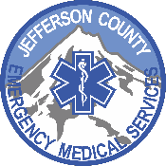
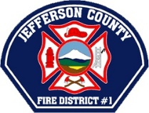

PUBLIC MEETING NOTICE

The City of Madras, Jefferson County, Jefferson County EMS and Jefferson County Fire District #1 will be presenting the final report regarding the feasibility study on a Fire/EMS merger. The public is encouraged to attend.

Wednesday, June 5, 2019 at 6:00 pm
Jefferson County Fairgrounds, Mackey Conroy Building
430 SW Fairgrounds Road, Madras

A copy of the feasibility study is available for viewing at
www.ci.madras.or.us on the Public Notices page.

Posted: May 29, 2019
- Madras Pioneer
- Jefferson County Clerk’s Office
- Madras City Hall
- Madras Post Office

